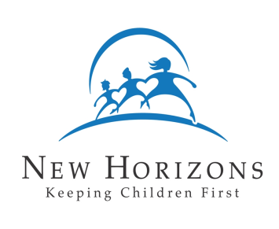
New Horizons Child Placing Agency
Family Profile – Children in the Home
(To be completed by either parent for each child now in the home)

Child’s Name:

Date: Age:

What five words best describe this child?

How does this child express the following feelings:

- Happiness

- Love / Affection

- Anger / Stress

- Disappointment / Frustration

- Sadness / Depression

How does this child’s teacher describe him or her on a good day?

What activities does this child enjoy the most?

What are the main activities that you do with this child?

What responsibilities does this child have at home?

Can you usually depend on this child to meet these responsibilities? Yes No

What is the child’s understanding of foster care or adoption?

In what ways will your fostering or adopting a child be beneficial for this child?

In what ways will your fostering or adopting a child be difficult for this child?

