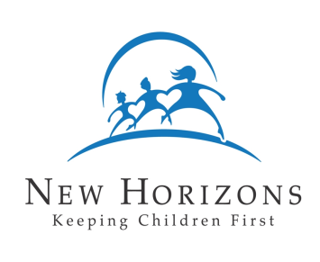
New Horizons Child Placing Agency

Family Profile – Child’s View of Family
(To be completed by each child under 12 years of age)

Child’s Name:

Date: Age:

Hello, I work with New Horizons. My job is to try and find families for children whose parents cannot take care of them. Your parents have talked with me about having such a child come to live in your home. I want to find a child who will fit into your family.

You can help me do this by telling me something about yourself and your family. Here are two ways you can tell me something.

- You can draw a picture of yourself, your home, and your family, and put the child who will be coming to live with you in the picture.

- Or, you can write a story about yourself, your home, and your family, and put the new child in your story.

Please write your story or draw your picture on this page. Use a pencil, a crayon, markers – whatever you like. Thank you for helping me.

