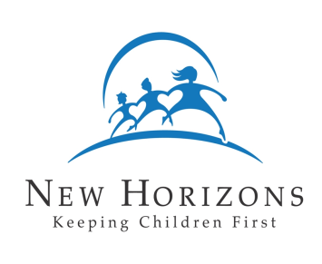
New Horizons Child Placing Agency

Family Profile – Other Adult’s View of the Family
(To be completed by each adult household member besides parents)

Name: Date:

- What is your relationship with the other members of your household?

- Were you involved in the decision to provide foster or adoptive care: Yes No

- How do you feel about the family’s decision to provide foster or adoptive care?

- Will you be involved in providing care for the foster or adoptive child? If so, how?

- What role will you fulfill in the life of the child?

- What experiences have you had with children?

- Will you be involved in discipline for the foster or adoptive child? Yes No

If yes, are you familiar with the New Horizons Child Placing Agency discipline policy?
Yes No

What type of discipline do you feel comfortable using with children?

- Do you have any other comments about foster or adoptive care?

