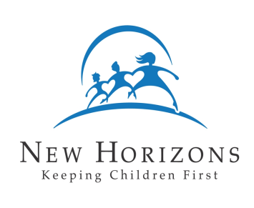
New Horizons Child Placing Agency
Family Profile – The Household

Name of Parents: Date:

- How do you and your spouse express the following feelings:

- Happiness

- Love/Affection

- Disappointment/Frustration

- Stress

- Sadness/Depression

- How are decisions usually made in the family?

- What issues cause the most disagreements? If an agreement cannot be reached, who makes the final decision?

- How are chores in your family divided? What happens when someone does not want to do his or her chore?

- If your family was in a crisis of some kind (financial, emotional, medical, etc.), to whom would you turn for help? How does this person(s) feel about you becoming a foster or adoptive family?

- How will becoming a foster or adoptive family affect:

- The amount of time you have with your children already?

- The amount of time you have alone and with your partner?

- The way chores are divided in your family?

- The amount of money you have?

- The condition of your home?

- Your relationship with members of your extended family (your parents, brothers and sisters, cousins, and so on)?

- What will you like most about being a foster or adoptive family?

- What parts of foster or adoptive care might cause the most difficulties?

- When necessary, can you leave work to take a child to counseling sessions, doctor’s visits, school meetings, family visitation (if appropriate) and so forth? Yes No
- How would you describe your home and neighborhood to the child who might be placed with you (or to the child’s parents)?

- Do you have pets? If so, please give each pet’s name and indicate what kind of animal it is and how long you have had it. Note: NH CPA requires foster families to document that each pet has received appropriate vaccinations within the last year.

If a child placed with you was afraid of your pet or became allergic to it, what would you do?

- Every family has rules. In your home:

- What rules are you most willing to bend?

- What rules are most serious when they are broken?

- How are privacy and nudity handled in your home?

- Describe your relationship with your neighbors?

- Who regularly visits your home?

How do these people feel about your becoming a foster or adoptive family?

- Both individually and as a family, what activities does your family enjoy?

