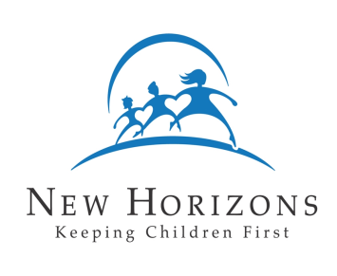
New Horizons Child Placing Agency

Family Profile – Youth’s View of Family
(To be completed by each young person from 12 to 17 years of age)

Hello, I work with New Horizons Child Placing Agency. My job is to find families for children whose parents cannot take care of them. I know your parents have talked with you about having such a child come to live in your home. I want to help them find a child who will fit into your family.

You can help me do this by answering the questions on the following two pages. Your answers will tell me something about yourself and your experiences.

Thank you for your help.

YOUR NAME:

TODAY’S DATE: YOUR AGE:

- Please write down five words that describe your personality.

- Write down five words that describe how you look.

- In what ways are you like your parents?

- In what ways are you different from your parents?

- What do you like best about school?

- What do you like least about school?

- Do you like to spend your time with lots of friends, a few friends, or mostly by yourself?

- If a new child comes to live with your family, what will you tell your friends about the new child?

- Image that I am bringing the new child to live in your home. What do you hope the child will be like? A boy or a girl? How old? What will the child like to do? What will he or she look like?

- Imagine again that I am bringing the new child to live in your home. As I am driving over, what would you like for me to tell him or her about you and your family?

Person doing interview Date

